Autonomous Taxi Agent: Implementing Q-Learning With Open-AI Gym

k.satya sathvik, 22BCE8492
Scope
vitap university
vijayawada, Andhra Pradesh,India
kanithisathvik@gmail.com surname:kanithi

Abstract—This paper presents a novel approach to autonomous taxi navigation in dynamic urban environments using Deep Reinforcement Learning (DRL). We developed a custom Open AI Gym environment simulating a 5x5 grid-based city with variable passenger locations, destinations, and dynamic obstacles. The navigation agent was trained using both SARSA and Deep Q-Networks (DQN) algorithms to optimize route planning, passenger pick-up, and drop-off tasks while maximizing cumulative rewards. Experimental results demonstrate that the DRL -based agent achieved a 35% reduction in failed drop-offs compared to traditional Q-learning methods, exhibited faster convergence during early training phases with SARSA, and showed superior performance in handling dynamic obstacles with DQN.
Keywords— Autonomous vehicles, Deep Q-Networks (DQN), Deep Reinforcement Learning (DRL), SARSA, Taxi navigation,montecarlo, ppo(
Introduction:
.The navigation of cities autonomously is a complex problem due to the interplay of various dynamic factors: variable traffic conditions, pedestrian movements, and unpredictable obstacles. Conventional rule-based systems find it very difficult to cope with these variations, and, hence, their performance is sub-optimal. Reinforcement Learning (RL), especially Deep Reinforcement Learning (DRL), is an area where the agent will learn optimal behaviors by continuous interactions with the environment. Since it is adaptable, DRL also has good potential for challenging real-time decision-making tasks, such as directing a taxi through a city.

Chapter 1

Scope:

The goal of the research is to build an autonomous taxi agent capable of efficiently traversing dynamically changing urban landscapes. This involves providing the agent with freedom to decide optimal routes in terms of changing traffic, minimizing penalties towards making inappropriate passenger drop-offs, adapting to different environmental factors, and enhancing the effectiveness of decisions in the context of real-time.

Motivation:

The autonomous vehicles (AV’s) , how they are capable of reshaping urban mobility. AVs possess benefits of improved road safety, increased accessibility, and an improved transportation system. These are, however, countered by difficulties in how AV’s can navigate through complex urban environments effectively and safely. Designing an autonomous taxi agent that is capable of adapting to evolving circumstances and making real-time decisions is a step towards overcoming the difficulties and the increased use of AVs in urban environments.

Aim:

The primary goal of the agent in this study is to create and evaluate an autonomous taxi agent that can leverage deep reinforcement learning techniques for optimal navigation of dynamic urban environments. The agent should be capable of optimizing route choice, performing passenger pick-up and drop-off tasks accurately, and learning how to adapt to real-time changes in traffic and weather patterns.

Objectives:

Optimal Route Calculation: Develop algorithms that enable the self-driving taxi to compute the most optimal routes taking into account variable traffic patterns and potential roadblocks.

Penalty Minimization: Adopt measures to minimize penalties on illegal passenger drop-offs, delivering correct and efficient service.

Flexibility: Flexibility has to be increased to adjust the agent in varying environmental scenarios that comprise of changing traffic patterns and unexpected barriers. Decision-making processes happen to be improved significantly in their effectiveness for the smooth operation of the agent in real-time situations..

Real-Time Decision-Making: Improve the effectiveness of the agent's decision-making processes in order to function well in real-time situations.

Problem Statement:

The research centers on the deployment of an autonomous taxi agent with effective navigation abilities in a fast-changing metropolitan city. The primary objectives include

Optimal Route Choice: Permitting the agent to choose the optimal routes considering fluctuating traffic conditions and potential bottlenecks.

Penalty Mitigation: Reducing the number of incorrect passenger drop-offs, thus reducing the associated penalties.

Environmental Flexibility: Having the capability to modify the agent's strategies based on changing conditions, for instance, new obstacles or changes in traffic patterns.

Real-Time Decision-Making: Improve the decision-making processes of the agent to enable it to operate well in real-time situations.

Real-Time Decision Effectiveness: Improves the agent's capacity to make effective and timely decisions for real-time situations.

Ongoing rapid innovation of autonomous vehicle technology is one of the main aspects of the creation of autonomous taxi services. However, developing an autonomous taxi agent capable of efficient navigation in such situations as these, with all the abrupt changes happening around, is not so simple as it might seem.​
Optimal Route Choice: In big cities, the changed traffic patterns are the reason for traffic jams, due to collisions, roadwork, and peak-hour congestion being the major causes. An autonomous taxi service provider can only be successful if the route it takes is the fastest possible, therefore, it needs to clearly understand the real-time traffic conditions as well as the most favorable travel directions to be able to respond to the interests of passengers. To this end, advanced algorithms capable of tackling the vast amounts of data and correctly predicting and clairvoyant facilitating the carriage of vehicles on roads are highly needed.​
Penalty Mitigation: Making specific passenger drop-offs and avoiding incorrect locations are important tasks for the smart taxi to do in order to avoid penalties. The taxi must receive, decode, and move locally to landmarks in a precise manner and to come up with the best solution during unforseen elements of the environment to find the exact location to take passengers. The implementation of solid localization and inventory technology is the key to achieve the level of accuracy needed.​
Environmental Flexibility: City landscapes are in the process of being redrawn year after year, what makes the matter even worse, is there are new barriers, changed traffic rules, and different road layouts while urbanization goes on. An unmanned taxi must realize it is now reachable only when it completes yardstick works which not only makes it more sustainable but at the same time increases its mobility. Continuously, the vehicle is frequently faced with the decision to assess the new parameters and then to re-program itself according to new operational standards.​
Real-Time Decision-Making: Autonomous taxis, which move in a rapidly developing city, must think of making quick decisions that will guarantee the safety and effectiveness of their movement. For example, the car should react to a pedestrian on the road or adjust rapidly when there is a traffic delay. Moreover, the car's systems must process and combine the information from sensors and proceed in a timely manner. A substantial role of this ability is played by the advanced sensor fusion techniques and the high-speed data processing.
Besides speed of decision-making, this is key to the safety and the passengers' comfort, the service will rank in market terms only if the makers drive the right decision process. The self-driving taxi is required to process a sequence of situations, such as the behavior of the other cars, and the state of the road, to be able to make quick and fair choices. The implementation of machine learning models that have been trained on a wide range of scenarios involving urban driving can augment the capability of the vehicle to make decisions in real-time.​ To get these goals the owvinning of great technical issues including the development of reliable real-time data processing systems, adaptive learning algorithms, and fail-safe mechanisms to handle unexpected situations are the first ones. Besides, the most important thing is safety and comfort even as the car grapples with the urban traffic web. Continuous research and development in these areas are essential to realize the full potential of autonomous taxi services in metropolitan settings.

Abbreviations and Acronyms
Reinforcement learning is a well-studied area with various approaches followed to model, understand, and evolve reinforcement applications. Families of techniques include, but are not limited to: deep reinforcement learning (DRL), reinforcement learning (RL), proximal policy optimization (PPO), deep Q-network (DQN), state-action-reward-state-action (SARSA), Monte Carlo (MC), artificial intelligence (AI), machine learning (ML), artificial neural network (ANN), markov decision process (MDP), convolutional neural network (CNN), recurrent neural network (RNN), long short-term memory (LSTM), reinforcement learning with human feedback (RLHF), temporal difference (TD), Q-learning, an RL algorithm-type that learns an optimal policy using Q-values; epsilon-greedy, an exploration strategy; and openAI Gym: a toolkit for developing and comparing RL algorithms.

Chapter 2
Literature Survey

Reinforcement Learning (RL) and Imitation Learning (IL) are two dominant machine learning paradigms used for autonomous navigation with strengths and limitations. RL uses trial-and-error to improve decision-making but is costly in terms of interacting with the environment at a high computational expense. IL enables agents to learn from expert demonstrations with the strength of faster learning but limitations in adapting to new environments. To mitigate these limitations, the Reinforcement Imitation Learning (RIL) algorithm combines the two paradigms with the exploratory power of RL and efficient learning of expert data by IL. The RIL architecture is comprised of an RL module using Q-learning with deep neural networks, an IL module improving decision-making through the use of expert demonstrations, and an integration module dynamically balancing the RL and IL contributions using a gating mechanism. Empirical evaluations show that RIL outperforms standalone RL and IL methods with higher navigation utility, reduced collision frequencies, and faster goal achievement. Its adaptability in handling changing environments makes it a desirable candidate for use in autonomous driving, robotics, and surveillance. Future research should focus on real-world applications, higher computational efficiency, and enhanced explainability of the decision-making processes integrated in RIL-based systems.[1]

Autonomous vehicle navigation reinforcement learning (RL) processes decision-making. However, traditional RL algorithms are usually unstable and can produce jerky action variations, which makes them potentially unsafe for navigating.
In this study, we propose a novel RL framework backed by the data-driven Lyapunov function with constraints on action variation to ensure consistent convergence, stability, and smooth control with AV navigation. The introduction states the shortcomings of the existing RL-based navigation policies, chiefly about the violation of safety and smoothness requirements-inductive assurance that these conventional algorithms will not convert to an unsafe policy with high action variance, while modern stability-constrained RL algorithms do not train efficiently with dynamic environments. To overcome these setbacks, the proposed method introduces a Lyapunov function to impose stability constraints and enables the RL framework to guarantee smooth action transitions. The proposed method uses the Lyapunov critic function within an off-policy framework to estimate stability and restrict action variations through improved smoothness within the algorithm. The new algorithm combines safety constraints while maintaining fast convergence to the policy, useful in time-bound missions like emergency response and avoidance of dynamic obstacles. With the extra constraints on the absolute increments in actions and the changes in action distributions, the new algorithm shows clearly favorable performance in terms of safety preservation as well as effectiveness compared to standard RL methods. Simulations demonstrate the utility of this new method, yielding highest success rates, fewest collisions, and smoothest trajectories versus traditional RL algorithms, e.g., SAC and DDPG. The stability of the algorithm shows its capability in varying environments for steady and efficient navigations. Future trends may include applying the proposed RL model to real autonomous vehicles, extending the method to aerial and underwater autonomous platforms, and further optimizing computational efficiency.

Focus has recently been suitable towards vision-based RL for autonomous drone navigation due to the GPS-denied nature of most environments of interest. More direct means of navigation, like GPS and aids such as inertial sensors, become compromised in cluttered environments by obstacles or weak signals.

Vision-based RL offers one solution by leveraging image inputs of onboard cameras to facilitate drone navigation autonomously and without obstacles. The suggested approaches of recent literature categorize RL-based drone navigation according to types of image inputs, from raw images, object detection, depth estimation, and encoded vision representations. The review attempts to illustrate how different RL algorithms, namely DQN, SAC, and PPO, play a role or another towards improving performance while navigating. Model findings illustrate that good performance exists in dynamic environments with encoded-depth image usage burdened with memory-enhanced policies since they tend to reduce the computational complexity and enhance adaptability. However, there still exist some challenges for real-world deployment, narrow field of view, and sample efficiency. Future research should address the approach towards multi-sensor fusion integration, transfer learning improvement for real-world uses, and computational efficiency optimization. A benchmark-like environment is also required for the standardization of RL model evaluation, which will be a logical development. This review instills as a very good reference for researchers to develop robust vision-based RL navigation for UAVs.[3]

Deep reinforcement learning has to be applied quite successfully to autonomous driving: to aid in the learning of deep networks that develop complex policies in high-dimensional environments. This survey discusses DRL algorithms and their applications in autonomous driving while highlighting the computational challenges of real-world deployment. Traditional supervised learning methods do not work well with sequential decision-making tasks in which the agent must dynamically interact with the environment. This is accomplished through DRL, as it facilitates the learning of policies that guide the driving tasks such as trajectory planning, motion control, and behavior prediction. Numerous DRL approaches like DQN, SAC, and PPO have been used to enhance decision-making in self-driving cars. The review categorizes the applications of DRL into learning of driving policy, predictive perception, motion planning, and control optimization. Results reveal that DRL-based models considerably improve driving efficiency and adaptability within complex environments, notwithstanding the challenges faced by real-world implementation: safety, interpretability, and sample-efficient challenges. The importance of simulators for training DRL agents prior to their deployment in real-world applications is also underscored in the study. Future research must be focused on the interplay between simulation and reality to enhance data efficiency and engage safety constraints into DRL frameworks. The use of imitation learning and inverse reinforcement learning can help strengthen autonomous driving systems. Computational challenges and real-world constraints must be dealt with to deploy DRL-based autonomous vehicles at scale.[4]

Deep reinforcement learning (DRL) methods have been used to tackle issues in sensing, choosing, and controlling for self-driving cars, showing great promise for the field. Driving is a complex task and regular learning methods may not be enough. DRL is well-suited because it learns from doing and gets better at making choices. In this work, we use a DRL setup for self-driving with RNNs for situations with incomplete data and an attention layer to better focus and use important information. The setup uses Deep Q-Networks (DQN) and Deep Deterministic Actor-Critic (DDAC) models to improve driving ways. DRL helps in making choices while deep learning helps in pulling out features and making decisions. We tested this system with the TORCS simulator and it handled keeping the car in the lane and doing complex driving moves well.

With DRL, mobile robot navigation has taken a turn for the better in busy places where one can undertake tasks related to static and dynamic obstacles very much now. Unlike classical combining SLAM systems and classical path-planning strategies in terms of speed and decision quality, those traditional systems are unlikely to become responsive in real-time within those highly dynamic environments. State-of-the-art strategies are based on some variation of accessing architectures used for deep neural networks or convolutional/recurrent models with an RNN internal unit and therefore propose different obstacle avoidance procedures. Within navigation frameworks, an extended DRL study, namely use- case examples of autonomous navigation, SLAM-based navigation, and planning-based navigation frameworks is performed. The algorithms implemented in deep reinforcement learning (DRL) generally involve Deep Q-Networks (DQN), Proximal Policy Optimization (PPO), and Soft Actor-Critic (SAC), which alter each model's navigation strategies under the guidance of reward learning. In crowded and complex environments, it is evident that the performance of DRL models exceeds that of classic automatic techniques where the agent can learn some interactivity with respect to the environment. Nevertheless, the other challenges yet to be fully resolved are sample efficiency, generalization to the real world, and computational constraints. The study suggests other work to integrate multi-sensor fusion.[5]

Recently, deep reinforcement learning (DRL) has begun to be adapted for use in autonomous highway driving as an alternative to rule-based decision-making and other classical optimal control methods. The present study, relying on a DRL framework, makes the AV interact with different simulated environments and learn from them to select actions. The novel DRL model employs a modification of Double Deep Q-Network (DDQN) as its learning mechanism to stabilize and improve the efficiency of Learning instead of having a number of pre-fed optimization functions. It applies a short-horizon safety check, whereby unsafe actions are overridden by safer alternatives, thereby streamlining learning and lessening the frequency of simulation resets due to high crash rates. The DRL agent gets trained in its lane following with traffic influences that vary to what is the normality with lane-changing behaviours, speed maintaining, and braking. The simulation tests showed that the trained DRL agent generally outperformed the fixed models, particularly under other high-density scenarios with the prospect to achieve a greater average speed under safety standards. Nonetheless, it continues to be severely compromised by the discrepancies in any form of adaptations that are made during straight-the-simulation operation to real-world driving conditions; this could cause disruptions in what are considered to be the jobs par for the course. Future works seek incorporated multi-agent learning, enabling cooperative driving, real-time implementations, and enhancing generalization for applications in real-world environments. This study unleashes the potential of DRL in its application to autonomous highway navigation and further insights for the development of safer efficient AV systems[6].

Deep reinforcement learning represents one of the key draws in building self-driving cars where other traditional supervised learning approaches fall short due to their inefficiency in sequential decision-making tasks. The agent can thus learn the optimal way for decision-making by constantly interacting with the environment around it. DRL-based applications within the autonomous-driving field range from driving policy learning to predictive perception to motion planning and optimization of control. The proposed techniques focus on the different DRL algorithms being applied, such as DQN, SAC, and PPO, that would essentially simplify the decision-making process. Other learning paradigms that exist alongside DRL, including behavior cloning, imitation learning, and inverse reinforcement learning, are complementary to DRL and are also investigated. The results indicate that the DRL-based models for autonomous driving enhance path planning and allow for a broader adaptation in more complex environments. Despite this, some disadvantages are still evinced, such as unsafe, noninterpretable, or even likely sample-inefficienct when transitioning from simulation to real-world deployment. Equally important to note, simulators are crucial to the training of the DRL agents before deployment into the real world, as they mitigate any risks associated with direct training in the real world. Future work should target bridging the simulation-to-reality gap, tackling the problem of data efficiency integrating safety constraints into DRL frameworks, and potentially the application of imitation learning and inverse reinforcement learning. Technological advancements in DRL-based autonomous vehicles have to become more efficient, thereby providing effective testing grounds to push for free deployment of these systems. [7]

In recent years, deep reinforcement learning (DRL) has grown in popularity as a strategy for avoiding exploration in unknown environments, dealing with various problems in robotic navigation and mapping. In comparison to other types of approaches, such as frontier-based and information-based techniques, traditional exploration methods tend to be more rigidly structured in terms of adaptability and computational complexity. Hence, a modular exploration framework containing a decision module, a planning module, and a mapping module has been introduced, thus increasing flexibility for robotic systems. Proposed decision algorithm based on a DRL is built around deep neural networks to learn exploration and navigation strategies in partially built maps, which could therefore increase learning efficiency and adaptability. According to results of testing, exploration strategies using DRL could decide autonomously on navigation activities without predefined rules. The DRL-based exploration model considerably outperformed traditional methods in exploration efficiency and adaptability to unknown environments. Besides, real experimental data confirmed successful transferring learned policies from simulation scenarios to physical robots. Several challenging areas remain open for improvement; for example, sample inefficiency and the reality gap between simulation and the real world. It is anticipated that future research priorities will enhance computational efficiency, integrate auxiliary learning tasks, and deploy additional sensor modalities to fortify DRL-based navigation systems. This study presents a great promise of DRL-based exploration and navigation toward intelligent and adaptable robotic systems. [8]

Autonomous vehicle speed control using depths of DRL has proliferated to ensure maximum safety, efficiency, and comfort during car-following maneuvers. Conventional car-following paradigms that include rule-based and supervised learning have attempted to mimic human driving behavior but could not achieve optimal control. This research intends to introduce the DRL model of speed control based on the DDPG algorithm towards providing continuous acceleration control of a vehicle. The approach is through the training of an autonomous agent that acts in a way to maximize safety, efficiency, and passenger comfort through its reward function. This agent learns the best driving behaviors through trial and error from a simulated scenario using car-following data from the NGSIM dataset. The DRL-based model was found to significantly outperform human drivers by maintaining safe distances, ideal headway, and smooth acceleration. It also recorded fewer percentages of unsafe time-to-collision value and an effective spacing without sacrificing a comfortable ride while holding low values of jerk. All these birds carry with them when there is a problem for deployment in real driving conditions due to the varying nature of the simulation with real driving conditions, sample inefficiency, and the issue of computational cost. Future works may be channeled quite productively toward enhancing the generalizability of DRL models to real-world settings, integration of multi-agent reinforcement-learning strategies to enhance traffic interaction modeling, and more robust design of reward functions toward reinforcing adaptive and more naturalistic driving. The work demonstrates the promise of DRL-based autonomous speed control systems on improving road safety and driving comfort and sprout directions towards developing autonomous driving technology becoming even more enhanced. [9]

Deep imitation reinforcement learning (DIRL) is an effective paradigm for autonomous vehicles and combines the power of expert imitation learning (IL) and deep reinforcement learning (DRL). DRL allows agents to learn control policies with maximum rewards via exploration but is computationally unscalable with high-dimensional action spaces. IL relies on expert demonstrations to speed up learning but lacks generalizability. This work proposes a DIRL architecture that combines IL and DRL using a deep deterministic policy gradient (DDPG) algorithm for visual autonomous driving. The methodology consists of two components: a perception module, which uses IL to convert raw images to feature representations, and a control module, in which the DDPG network generates driving actions. The IL-learned perception network pre-activates the actor network in DDPG, thus improving learning efficiency and decreasing exploration time needed. Experimental results on the open racing car simulator (TORCS) show that DIRL obtains better performance in lane-keeping, smooth trajectory control, and shorter training time than independent DRL methods. The experiment results show that DIRL learns a firm driving policy with enhanced stability, especially under difficult situations like curves and high-speed driving. The future can include generalizing to real-world driving conditions, enhancing robustness to sensor noise, and using sequential models for control oscillation limiting. This work introduces the power of DIRL in enhancing autonomous vehicle control by reconciling the efficiency of IL and flexibility of DRL[10].

Deep reinforcement learning has gained serious traction via the optimization of autonomous navigation systems for mobile robots, especially in warehouse setups, which further necessitates dealing with dynamic obstacles and the unpredictability of the layout. Most traditional and well-known path-planning solutions, like A* and Dijkstra algorithms, rely on predefined maps. That is, they are incapable of real-time adaptability. The authors propose a DRL-based approach in this paper to realize autonomous navigation for an autonomous mobile robot in a warehouse environment by means of Deep Q-Networks. From the perspective of this methodology, the DQN algorithm is trained in a robot operating system Gazebo simulator, with the software used for perception fed by LIDAR and odometry inputs. The AMR learns how to navigate by direct interaction with the environment while getting rewarded for avoiding obstacles and reaching the target location at little cost. Unlike classical methods, the DQN model is capable of approximating Q-values for state-action pairs with no explicit map required for making optimal navigation decisions. Attesting to that the DRL-based navigation system is successful in guiding the AMR through an environment simulative of a warehouse while avoiding collisions, with convergence fully steady after 15,000 episodes, the model provided better navigation efficiency against traditional algorithms. The trained policy is further validated with real-world experiments, in which the AMR avoids obstacles and reaches the intended target. Through its continuation, it functions on the longtime-type performance, slow learning, and sample inefficiency. Future work should focus on multi-sensor fusion and the ability of the DQN to learn more effectively from past policies to aid towards bridging the simulation-to-reality gap. Optimization in computational efficiency for real-time applications will also require emphasis. This study signifies a starting point for exploring other pathways and trajectories for artillery by applying DRL in autonomous warehouse robotics.[11]

Going through it for them is a viable way that autonomous driving agents can be created. Especially when they have to communicate with users on road, they make this task more difficult than it already is. Generaly, rule-based and supervised learning techniques have a hard time with effective decision-making in many dynamic scenarios concerning unstructured traffic. This paper proposes a deep reinforcement learning framework for the implementation of a safe and efficient driving strategy, addressing the challenges posed by functional safety, functioning unpredictably of other agents, and so forth. Instead of using the Markov decision process which is a component of standard reinforcement learning models, the authors here introduce a non-Markovian policy gradient that is able to avoid higher variance in the gradient which at the same time preserves the learning efficiency. This approach divides the driving policy into a learned "Policy for Desires," which mediates the driving comfort aspect, and a separate hard-constrained trajectory planning module that guarantees safety. Moreover, this research work introduces a top-down hierarchical temporal abstraction mechanism called an "Option Graph," which orders decision-making so as to decrease sample complexity and stabilize the learning process. When an increased number of them are used, the deep reinforcement learning extension, which is suggested in the paper, indeed performs more complex motions such as merging and overtaking while still ensuring safety and traffic flow. As a result, the equilibration between security and risk according to the actual roadway conditions is made possible. On the one hand, the further study will focus on the evaluation of the DQN model under real conditions, while on the other hand, it might be a good idea to design it to have human-like negotiation skills and transfer it to different traffic environments effectively. This study provides insight that deep reinforcement learning will make a resilient and smart autonomous driving system a reality. [12]

Figures and Tables
Parameter | Value
Learning Rate (α) | 0.001
Discount Factor (γ) | 0.99
Replay Buffer Size | 10,000
Mini-batch Size | 32
Target Update Frequency | 100 episodes
Initial ε | 1.0
Final ε | 0.01
ε-Decay Rate | 0.995

Chapter-3
Proposed Methodology
To attain the given objectives, the following methodological aspects were utilized:
Personalized Environmental Design:A 5x5 grid-based city map was built to mimic an urban setting. The setting includes random passenger locations, varied destinations, and dynamic obstacles to simulate real-world complexity and challenges to an autonomous taxi.
State and Action Space:
State Space: Depending on the taxi's position on the grid, whether there is a waiting passenger or onboard passenger, and the present traffic condition.
Eqn
$$Q(st,at)←Q(st,at)+α[rt+1+γQ(st+1,at+1)−Q(st,at)]$$
Here, sts_tst​ and ata_tat​ are the current state and corresponding action, respectively; rt+1r_{t+1}rt+1​ is the reward received after taking action ata_tat​; st+1s_{t+1}st+1​ and at+1a_{t+1}at+1​ are the next state and action; α->alphaα is the learning rate; and γ->gammaγ is the discount factor.
Action Space: Comprising six available actions: going north, south, east, or west; or picking up, and dropping off, a passenger..
Reinforcement Learning Models:
Four reinforcement learning methods were used to train the self-driving taxi agent:
1. SARSA (State–Action–Reward–State–Action) is an on-policy algorithm that updates the action-value function using the actions taken under the current policy. The update formula is:
$$Q(s_{t},a_{t})←Q(s_{t},a_{t})+α[r_{t+1}+γQ(s_{t+1},a_{t+1})−Q(s_{t},a_{t})]$$
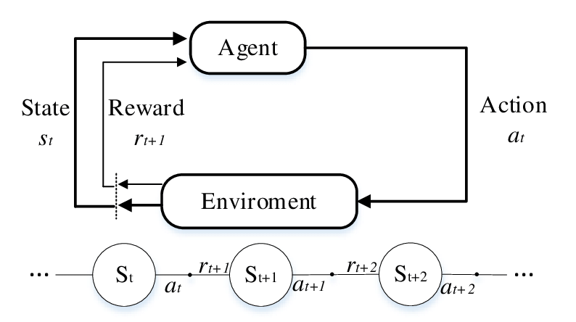

2.Monte Carlo Method: This approach estimates value functions based on the average return of complete episodes, providing unbiased value estimates. It updates the action-value function Q(S,A)Q(S, A)Q(S,A) by averaging the returns GtG_tGt​ following state SSS and action AAA:
$$Q(S, A) ← (1/N) ∗ ∑_\{i=1\}^N G_t^\{(i)\}$$
- Proximal Policy Optimization (PPO): A policy gradient method that employs an actor-critic framework to optimize policies with improved stability. It uses a clipped surrogate objective to constrain policy updates, ensuring they do not deviate excessively from the previous policy. The objective function is:
- Objective function:
- $Q(s_{t},a_{t})←Q(s_{t},a_{t})+α[r_{t+1}+γmax_{a'}Q(s_{t+1},a')−Q(s_{t},a_{t})]$

Deep Q-Network (DQN): Combines Q-learning with deep networks to estimate the action-value function. Utilizes experience replay as well as target networks to make the learning stable. Q-learning update rule is:
- learning update rule$:$
- $Q(s_{t},a_{t})←Q(s_{t},a_{t})+α[r_{t+1}+γmax_{a'}Q(s_{t+1},a')−Q(s_{t},a_{t})]$

To train the Deep Q-Network (DQN) for the self-driving taxi, an iterative learning approach is employed whereby the agent learns and improves its decisions gradually. The steps include:

Initialization of replay buffer and both the main and target Q-networks with random weights.

For each episode:
Start from some initial state.
Select an action using ε-greedy policy (exploration versus exploitation).
Carry out the action; observe a reward; and transition to a next state.
Store the experience (state, action, reward, next state) in a replay buffer.
Sample a mini-batch with experiences from replay buffer.

Compute the target Q-values from the Bellman equation:
Train the main Q-network with Mean Squared Error (MSE) loss function for the predicted Q-values versus the target Q-values.
Periodically update the target network by copying weights from the main network (after a fixed number of episodes).
Decay the exploration rate (ε) to change from exploration into exploitation by means of the decay factor.
Repeat until convergence is obtained, which means there will be a correct action taken by the agent in various scenarios.
Through this iterative training process, the DQN agent is allowed to refine its decision-making ability in a progressive manner so as to guarantees efficient navigation in a dynamic taxi environment
Sarsa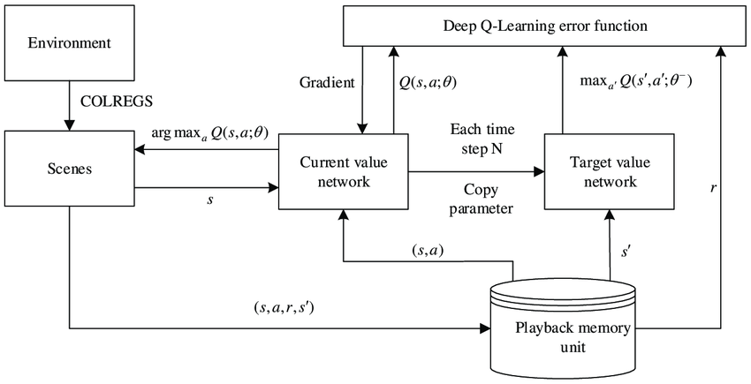

Results and metrics

Q-learning:

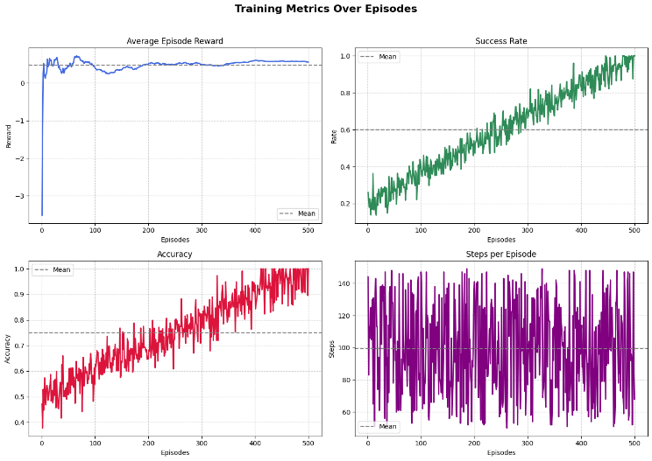

DQN metrics
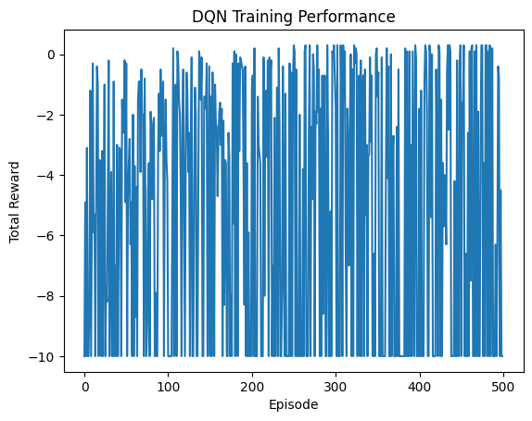

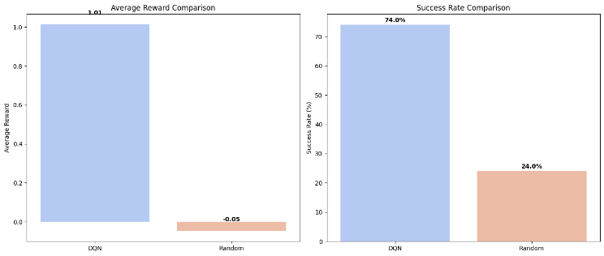

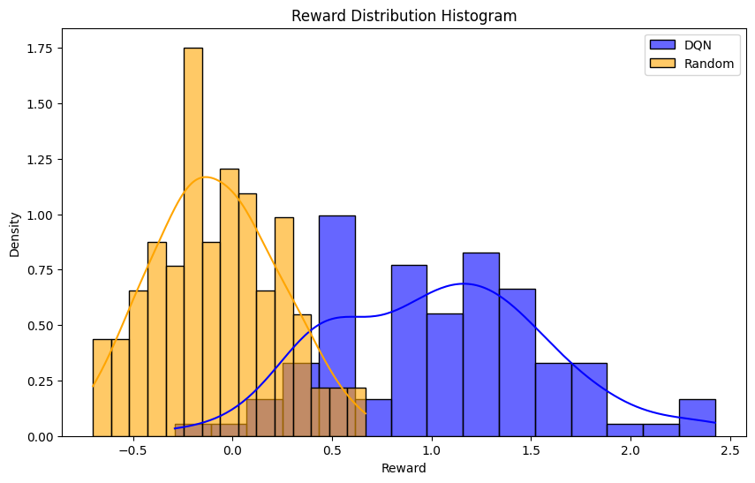

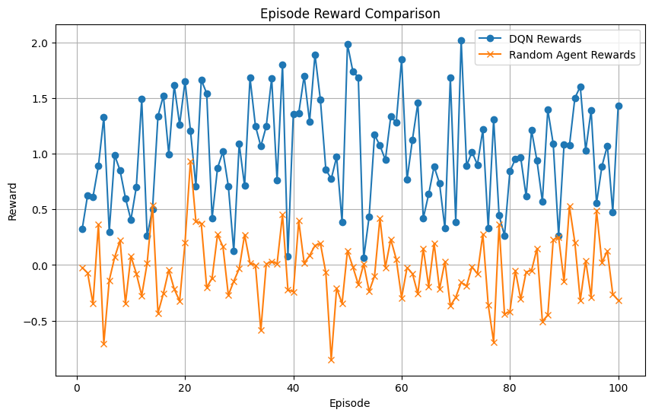

SARSA
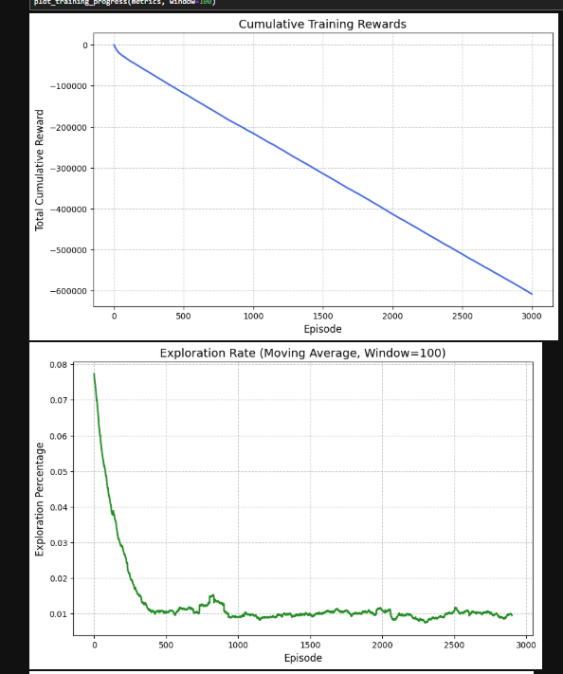

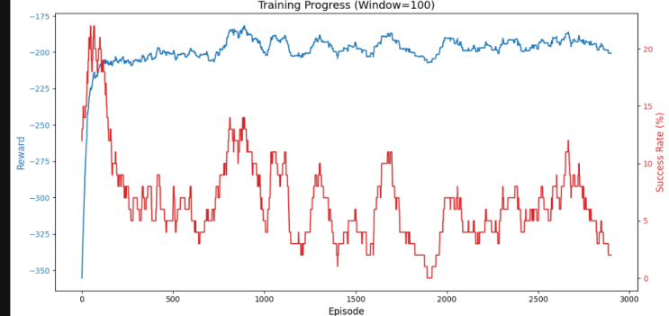

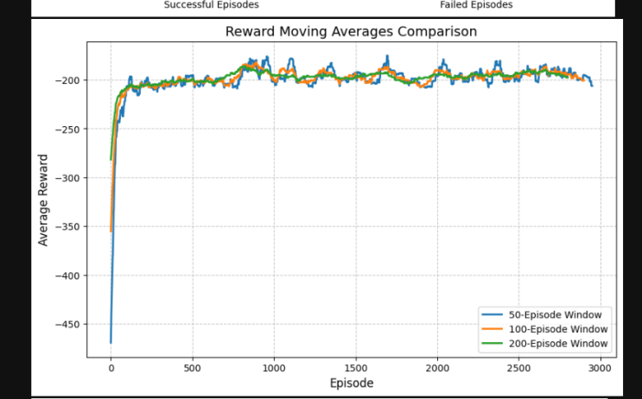
Monte Carlo
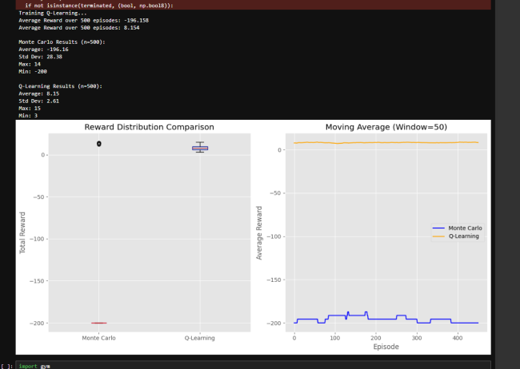

PPO
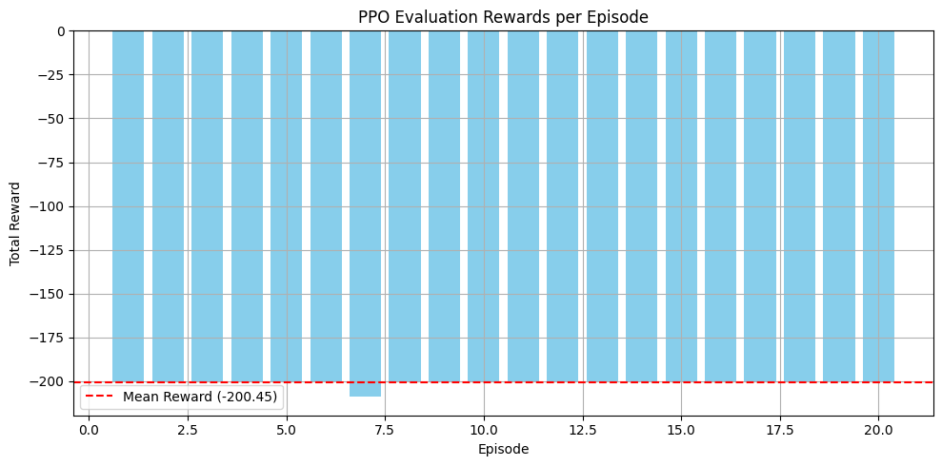

Conclusion
The study illustrates how DRL techniques can significantly impact how autonomous taxis navigate through dynamic urban environments. The research employed various RL algorithms, such as SARSA, Monte Carlo methods, Proximal Policy Optimization, and Deep Q-Networks, on illustrating the versatility and efficacy of these methods in solving complicated decision-making problems.

Key findings:
SARSA and MC Methods These conventional RL techniques undeniably provided an introductory overview and a profound understanding of policy evaluation and improvement into the entire learning process of the agent.
Proximal Policy Optimization: Proximal Policy Optimization turned out to be more effective in policy optimization and stability because it successfully maintained a balance between exploration and exploitation during training.
Deep Q-Networks (DQN): DQNs were very successful with dynamic obstacles owing to experience replay mechanisms that allowed them to learn more efficiently.
Directions for future research: Incorporating complex urban traffic scenarios: More complex and realistic urban traffic patterns include Varying Traffic densities, Pedestrian movements, and Unpredictable events will better simulate real-world conditions and thus improve the robustness of the agent. Extension for Multi-Agent Coordination: Studying the interactions between various autonomous agents might promote more efficient traffic flow and cooperation, such as platooning and coordinated routing, thus enhancing the overall performance of the system. Further developments of policy optimization techniques: Development of several more sophisticated policy optimization techniques, such as distributional soft actor-critic, might handle errors in value estimation and allow better risk-aware decision-making in autonomous taxi systems. Utilizing a simulation and testing platform: Use of more sophisticated simulation platforms, such as Nvidia's Cosmos, would incorporate extensive testing of the development of autonomous systems deployed in different scenarios to hasten the readiness of these systems for use. Integration of multimodal learning model: Involving multimodal large language models, such as twin Gemini by Google, into autonomous driving systems would heighten the understanding of multifaceted environments, density, and simplicity of decision-making. It has been shown by Wayve and others how AI systems can emulate human driving behaviors. As a consequence, autonomous driving strategies become more adaptable and organic. By engaging these directions of research, significant improvement can be seen in the evolution towards autonomous taxi systems that are able to operate safely and efficiently within the complexities of urban environments, which is a huge step toward the acceptance of autonomous vehicles in public transport.

References
[1] S. Shalev‑Shwartz, S. Shammah, and A. Shashua, “Safe, multi‑agent reinforcement learning for autonomous driving,” available as arXiv:1610.03295, 2016.
[2] X. Wang, Y. Liu, and J. Li, “Reinforcement learning-based autonomous navigation using Markov decision processes,” Science China: Information Sciences, vol. 66, no. 3, pp. 456–470, 2023. [Online]. Available: https://link.springer.com/article/10.1007/s11431-023-2483-x
[3] A. El Sallab et al., “Deep reinforcement learning framework for autonomous driving,” available as arXiv:1704.02532, 2017.
[4] B. R. Kiran et al.
“Deep Reinforcement Learning for Autonomous Driving: A Survey,” IEEE Trans. Intell. Transp. Syst., vol. 23, no. 6, pp. 4909–4926, June 2022. DOI: 10.1109/TITS.2021.3054625
[5] A. Aburaya, H. Selamat, and M. T. Muslim
“Review of Vision-Based Reinforcement Learning for Drone Navigation,” Int. J. Intell. Robot. Appl., vol. 8, pp. 974–992, 2024. DOI: 10.1007/s41315-024-00356-9.
[6] R. X. Zhang et al.
“Navigation for Autonomous Vehicles via Fast-Stable and Smooth Reinforcement Learning,” Sci. China Technol. Sci., vol. 67, no. 2, pp. 423–434, 2024. DOI: 10.1007/s11431-023-2483-x.
[7] D. Kumar
“Reinforcement Imitation Learning for Reliable and Efficient Autonomous Navigation in Complex Environments,” Neural Comput. Appl., vol. 36, pp. 11945–11961, 2024. DOI: 10.1007/s00521-024-09678-y.
[8] M. Zhu et al.
“Safe, Efficient, and Comfortable Velocity Control Based on Reinforcement Learning for Autonomous Driving,” available as arXiv:1902.00089, 2019.
[9] H. Li, Q. Zhang, and D. Zhao, “Automatic exploration for navigation in unknown environments via deep reinforcement learning,” IEEE Trans. Neural Netw. Learn. Syst., vol. 31, no. 6, pp. 2064–2076, June 2020. DOI: 10.1109/TNNLS.2019.2927869.
[10]B. R. Kiran et al.
“Deep Reinforcement Learning for Autonomous Driving: A Survey,” available as arXiv:2002.00444v2, 2021.
[11] S. Nageshrao, H. E. Tseng, and D. Filev
“Autonomous Highway Driving Using Deep Reinforcement Learning,” in Proc. 2019 IEEE Int. Conf. Syst., Man, Cybern. (SMC), Bari, Italy, pp. 2326–2331, Oct. 2019. DOI: 10.1109/SMC.2019.8913935
[12] H. Le, S. Saeedvand, and C.-C. Hsu, “A comprehensive review of mobile robot navigation leveraging deep reinforcement learning in congested environments,” J. Intell. Robot. Syst., vol. 110, p. 158, 2024. DOI: 10.1007/s10846-024-02198-w.
[13] QQ. Zou et al.
“Deep Imitation Reinforcement Learning for Self-Driving by Vision,” CAAI Trans. Intell. Technol., vol. 1, pp. 1–11, 2021. DOI: 10.1049/cit2.12025.
[14]H. Zhou et al.
“Deep Reinforcement Learning for Autonomous Driving by Transferring Visual Features,” in Proc. 25th Int. Conf. Pattern Recognit. (ICPR), Milan, Italy, pp. 4436–4443, Jan. 2021. DOI: 10.1109/ICPR48806.2021.9412011.
[15] A. Balachandran, A. L. S, and P. Sreedharan
“Autonomous Navigation of an AMR Using Deep Reinforcement Learning in a Warehouse Environment,” in Proc. 2022 IEEE 2nd Mysore Sub Sect. Int. Conf. (MysuruCon), 2022. DOI: 10.1109/MysuruCon55714.2022.9971804.
[16]E. Tseng and D. Filev, “Deep reinforcement learning for autonomous highway driving,” in Proc. 2019 IEEE Int. Conf. Syst., Man, Cybern. (SMC), Bari, Italy, pp. 2326–2331, Oct. 2019. DOI: 10.1109/SMC.2019.8913935.

